What is Refractometer? Mention 15 auto refractometers and their USPs with detailed analysis. What could be the potential new technologies that can be implemented?

**Definition-**

**Refractometers are tools that measure and categorise substances based on their refractive indices (RI). Refractive index, or RI for short, is a special attribute relating to the speed of light as it travels through a substance. Its definition is the ratio of the speed of light in a vacuum to that of the test substance.**

Types of refractometers-

Abbe refractometer

The Abbe refractometer was the first scientific tool for precisely determining the refractive index of liquids. It was named after its creator Ernst Abbe (1840–1905). An Abbe refractometer's measurement methodology is based on the entire reflection concept.

Liquids are measured using Abbe refractometers. You might choose reference media glasses (prisms) with high refractive indices. Mirror reflection causes light from a radiation source to strike a double prism. This so-called Abbe double prism is sandwiched with a few drops of the sample. Only if the angles of incidence at the interface are smaller than the critical angle of total reflection do the incident light beams pass through the double prism and sample.

Handheld refractometers

It is quite simple to use the adaptable handheld refractometers. Numerous applications are feasible as a result of the variety of measuring scales that are readily available. Handheld refractometers are used by beekeepers to determine the water content in honey, by wine producers to determine the sugar content of the fruit and the grape must, and by aquarists to determine the salt content of water in marine aquaria.

A small drop of liquid on the measuring prism is sufficient to determine refractive index. Held against a light source, the measured value can be read via the eyepiece on the scale. The vertical scale is intersected by a horizontal boundary line at the measured value.

Digital refractometer

Digital refractometers operate in the same way as handheld refractometers, but with an automatic determination and readout of the boundary line. They offer reduced inter-operator variability, and greater precision than manual handheld refractometers, and are typically available with a selection of common scales.

Automatic refractometer

refractometer automatically

Automatic refractometers completely eliminate differences in measured results between operators, and provide the highest level of accuracy. In contrast to manual refractometric measurement under uncontrolled environmental conditions, it is possible, for example, to measure the refractive index of the sample at different temperatures or light wavelengths. Automatic refractometers are found mainly in laboratory applications, where precise measurement under highly controlled conditions is required.

Dark, cloudy, and even opaque samples such as mustard, ketchup or mayonnaise can easily be measured with the help of fully automated, modern refractometer.

Process refractometer

Process refractometers enable continuous refractive index analysis, eliminating the need to separate samples and send them to a control lab. These instruments are made up of sensors that are connected to a control box and are either placed inline or in a bypass. This control box typically provides a digital readout and output. Like the other advanced refractometers (i.e. all except Abbe-type and handheld), they operate on the measuring principle of total refraction by determining the critical angle of monochromatic light of a range of angles of incidence.

process refractometers can require zero human involvement during measurement, and can provide real-time measurement data process medium

AUTO REFRACTOMETRS-

Auto Refractometer is an instrument by which we can assess Spherical, cylinder and Sphero cylinder power easily. In this instrument, Near Infrared Radiation (NiR) is used to determine Refractive Error.

**Auto-Refractometrs in the market-**

### 1.[NIDEK RKT-7700](https://www.ophthalmetryoptical.com/autorefractor/rkt-7700.html" \t "_blank)

### PRICE- ($5,050.00)

USP- RELIABLE, SPACE SAVING AND PROVIDES 3-D AUTO TRACKING AND SHOOTING INCREASING EFFICIENCY.

Buy this state-of-the-art NIDEK Autorefractor Keratometer Tonometer RKT-7700 and put an end to the days of slow and unreliable retinoscopes.

The RKT-7700 is an innovatively designed device that fulfills every optometrist's dream. It is the first model of autorefractor keratometer and non-contact tonometer.

The RKT-7700 is a versatile device with multiple functions. The equipment includes an automatic refractometer, keratometer and tonometer. A tonometer helps determine intraocular pressure, or the fluid pressure in the eye.

It is used to test for glaucoma

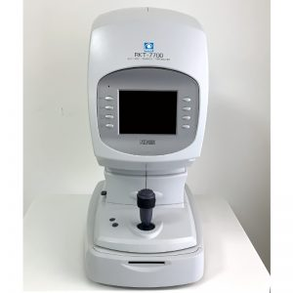

### 2. [Topcon KR-8000PA](https://www.ophthalmetryoptical.com/autorefractor/kr-8000pa.html)

### PRICE- ($5,890.00)

USP- ADAPTABLE AND HIGH EFFICIENCY.

A high tech auto refractor and auto keratometer for corneal mapping and the Topcon KR-8000PA is exactly what you need.

The Topcon KR-8000PA is a computerized corneal color mapping system that combines an autorefractor and an autokeratometer at a fraction of the cost of each piece of equipment. This not only saves money, but also improves the efficiency of service delivery.

The automatic tracking and automatic measurement of this KR 8000PA facilitates operation and provides object data where the results are unmatched in terms of reliability and accuracy.

The color mapping software used in this device has adjustable parameters that improve clinical assessment and allow contact lenses to fit the screen. This device enables three functions. Keratometry, refraction and corneal mapping in one station. It also features contact lens fitting capabilities, direct connection to CV systems, auto-alignment and auto-measurement. It can also be used for early detection of asymptomatic keratoconus.

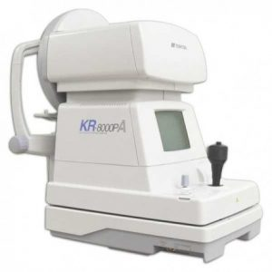

### 3. [Tomey RT 7000](https://www.ophthalmetryoptical.com/autorefractor/tomey-rt-7000.html)

### PRICE- ($5,250.00)

USP- SIMPLE AND EASY TO OPERATE.

The Tomey RT 7000 is an advanced and affordable auto-refracting keratometer that also functions as a topographer. Equipped with functions that allow comprehensive ophthalmic examinations without moving between stations.

With one touch, you can switch from reference keratometer mode to corneal topography mode. You can also quickly align the center of your eyes with the center of the screen.

This Tomey RT 7000 Autorefractor Keratometer Topographer feature allows him three functions in one device. A color TFT LCD screen makes it easy to measure pupil and corneal diameters.

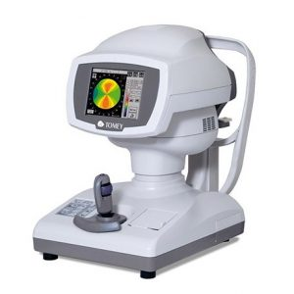

### 4. [NIDEK ARK-30](https://www.ophthalmetryoptical.com/autorefractor/ark-30.html)

### PRICE- ($2,950.00)

USP- PORTABLE, LIGHT AND BUDGET FRIENDLY.

The NIDEK ARK-30 handheld optometry device is one of the most affordable devices in optometry. The ARK-30 device enables measurements of disabled and wheelchair-bound patients.

The ARK-30 offers a high degree of mobility especially for refractive procedures in the operating room.

The NIDEK ARK-30 is lightweight and portable, has data storage for 30 people, and enables wireless communication and information sharing. These features enable fast and accurate measurements. Its main features include auto shot, AI metering and focus indication functions. A total overhaul by Marco 8/2016 is the reason for the reliability and accuracy of the device. With its elegant design, the lid transforms into a fully functional tabletop refractor.

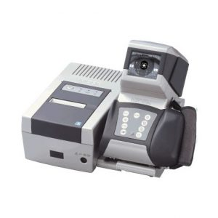

### 5. [ZEISS VISUREF 100](https://www.ophthalmetryoptical.com/autorefractor/zeiss-visuref-100.html)

### PRICE- ($2,999.00)

USP-REDUCES LODGING EFFECTS, EASY TO USE.

Zeiss Visuref 100 provides ophthalmology with accurate and reliable data. It is intuitive and can be used for refraction measurements in people with IOL implants. It also has an auto fog feature that includes an infinity scene to reduce the camp effect.

The Zeiss Visuref 100 has a measurement range of -25 D to +22 operation and D mode, all of which are used for contact lens corneal diameter, keratometry, refraction and base curve measurements. It also features a motorized chinrest and a 6.4-inch tilting TFT color LCD screen. There is also an integrated thermal printer and RS-232 interface.

# 6. Huvitz HRK-1 Autorefractor

**PRICE-($4105.00)**

USP- HIGH ACCURACY, HAS TOUCH SCREEN DISPLAY, FAST.

The Huvitz HRK-1 Automatic Refractometer/Keratometer offers optometrists better performance and greater measurement accuracy at an affordable price. The HRK-1 eliminates the challenges associated with high diopters and uses ring signaling to provide more accurate readings of the patient's eye system. The industry's only auto-tracking of her Y-axis automatically determines the patient's eye level, reducing measurement time.

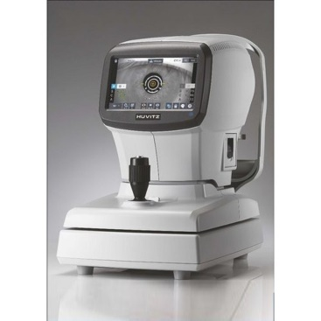

# 7. EYEVIS Refractometer Excellence R5

PRICE- ($4100.00)

USP-ACCURACY UPTO 5 DECIMALS.

Excellence refractometers provide measurements of many challenging samples with up to 5 decimal places of precision

Measurement of Brix and refractive index

Intuitive One Click™ User Interface

Establish a range of sample tolerance limits and get instant QC results

Measurement range of refractive index 1.32 to 1.58

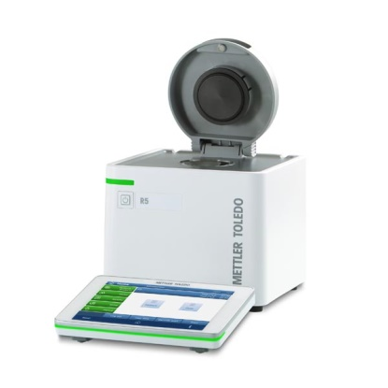

# 8. Topcon Auto Refractometer RM 800

**PRICE-(($7847.00)**

USP-LIGHT IN WEIGHT AND ACCURATE.

The Topcon RM-800 Automatic Refractometer incorporates the latest in design technology and ergonomics. The RM-800 features a bright new 8.5 inch color touch screen panel to control key functions. Joystick operation is improved as it is 23% lighter than its predecessor. Topcon systems are known for their accuracy with proven rotating prism technology. The new RM-800 also features this technology, so you can rest assured that accurate and stable refraction measurements are the norm.

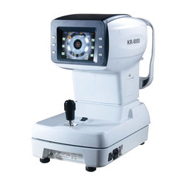

**9. Auto Refractometer Matronix Q30+**

**PRICE-($1617.00)**

USP-CONSISTENT MEASUREMENTS AND CHEAP.

The most advanced technique of chart output for quick and clear measurement of charts. Common optical technology, consistent measurements, accurate numbers.

The most advanced technique of chart output for quick and clear measurement of charts. Common optical technology, consistent measurements, accurate numbers. intraocular lens mode

Accurate and Reliable

Dual CEO camera technology with high resolution 5.7 inch color LCD display

Modern SMPS power system allows full operation under low or fluctuating supply voltages

The state-of-the-art in graphic output, graphics are measured quickly and clearly. Common optical technology, consistent measurements, accurate numbers. intraocular lens mode

Accurate and Reliable

Dual CEO camera technology with high resolution 5.7 inch color LCD display

Modern SMPS power system allows full operation under low or fluctuating supply voltages

**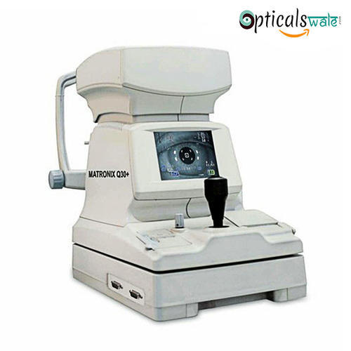**

# 10 Shin-Nippon Auto Refractometer  K-900

**PRICE- ($6,600.00)**

USP-IMPROVED ACCURACY AND IOL MODEL.

The sophisticated form, soft curves, and attractive colors of high-quality two-tone metallic and mother-of-pearl match any interior and appeal to customers with an atmosphere of trust.

Feather touch sensor button

Spring-touch sensor buttons used to interface with the screen enable responsive and precise operation.

Newly designed optical unit with improved accuracy

. Reliability warning indicator display has been added.

Improved side flaps, headrest and chinrest

Side flaps mounted on both sides of the measurement window allow light to be blocked, resulting in high accuracy. Minimize patient stress by changing the shape of the forehead and chin rests.

new joystick

A completely redesigned joystick shape and top button allows operators to control the device with more precise and intuitive movements. Redesigned IOL Mode [Color Focus Display]

The newly designed intraocular lens mode makes it easier to measure patients with intraocular lenses, which was previously difficult to measure.

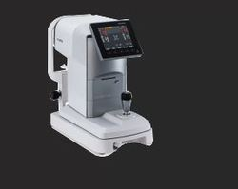

# 11. Grand Seiko Autorefractometer GR-2200

**PRICE-($4,100.00)**

USP-ELECTRIC CHIN REST, PRECISE MEASUREMENTS AND ADVANCED IOL MODEL

**GR-2200 Grand Seiko Auto Refractometer has been widely used to assess the refractive error. It is used to measure the degree of refractive error in the eye, and is suited well toward applications such as differentiating corneal from lenticular aberrations, and assessing pre-and-post refractive surgery patients. GR-2200 Grand Seiko Auto Refractometer can be availed at feasible prices.**

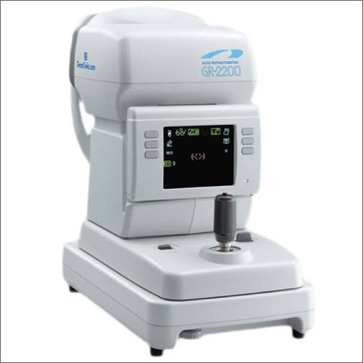

**12. OPTIC RM-9800**

**PRICE-($2,700.00)**

USP-VERY ACCURATE AND AUTOMATIC CHIN REST.

Very accurate

Advanced optical path system

retro lighting

One-touch lock & electric movement

Fast and user-friendly operation

Motorized movement of chinrest

Auto tracking function

Pupil and corneal diameter measurements (white to white).

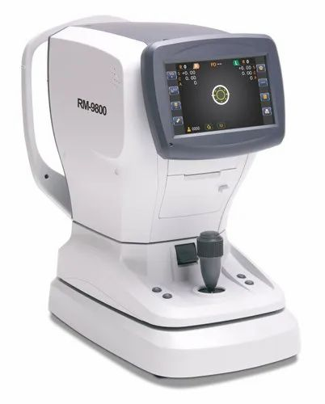

# 13. LENSit RM-9600 Auto Refractometer

**PRICE-($2,400.00)**

USP- USER FRIENDLY, AUTOMATIC PRINTER AND IOL MODEL.

The LENSit automatic refractometer uses an ARM processor and the latest image processors to make the system fast and accurate. The image processor creates sharp images on the 5.7-inch tilting screen. Using Japan's sophisticated optical path system, humanized automatic fog measurement method, reduce the error caused by adjustment and achieve more accurate measurement.

With optical auto-tracking system, more consistent and more stable.



# 14. Auto Refractometer AR-9

**PRICE- ($ 1,800.00)**

USP - OPTICAL PATH SYSTEM.

The LENSit automatic refractometer uses an ARM processor and the latest image processors to make the system fast and accurate. The image processor creates sharp images on the 5.7-inch tilting screen. Using Japan's sophisticated optical path system, humanized automatic fog measurement method, reduce the error caused by adjustment and achieve more accurate measurement.

With optical auto-tracking system, more consistent and more stable.

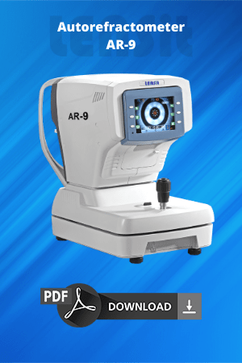

**15. Automatic keratometer ERK-9100**

**PRICE- ($ 8,880.00)**

USP- MOST ACCURATE, EASY TO USE AND LATEST.

The Ezer ERK-9100 Autorefractor Keratometer Aberrometer is fast, accurate, durable and affordable. The Ezer ERK-9100 is a powerful and accurate diagnostic tool that provides doctors with fast and reliable data. The flexible and intuitive modes of operation of this full-featured device enable ophthalmologists to perform examinations faster and gather more accurate information about the patient's eye condition. The Ezer ERK-9100 combines the functionality of an autorefractometer, keratometer, and aberrometer into one easy-to-use device, so the Ezer ERK-9100 can measure corneal curvature, refractive error, and advanced vision up to 3rd order. Perfect measurement of aberrations. This makes it the best option for ophthalmologists who prescribe contact lenses and glasses and need accurate data to diagnose eye conditions. The Ezer ERK-9100 is easy to use, affordable, and more accurate than most other auto-refracting keratometer aberrometers on the market, perfect for any ophthalmic practice!

3-in-1 Automatic Refractometer/Keratometer/Aberrometer

The advanced design of the ERK-9100 combines refractive index, keratometry and aberration measurements into one product. Users can choose to take measurements individually or simultaneously, providing ophthalmologists with a convenient and affordable 3-in-1 solution.

In addition, the ERK-9100's incredible accuracy and advanced features enable physicians to collect advanced eye data faster for their patients to provide better care.

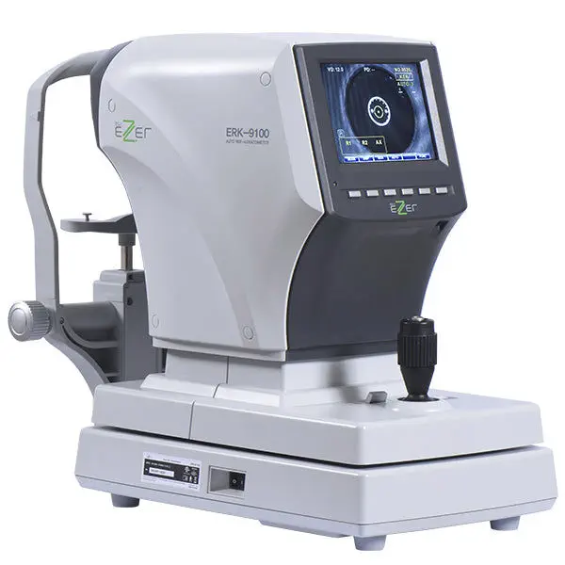

REFERENCES-

1. medicalexpo.com/prod/us-ophthalmic/product-100395-1031269.html
2. <https://usophthalmic.com/products/erk-9100>
3. <https://dir.indiamart.com/impcat/auto-refractometer.html>
4. <https://tealfeed.com/us-auto-refractometer-market-2022-expected-bfobn>
5. <https://www.researchgate.net/publication/8457812_A_Comparison_of_Autorefractor_Performance>
6. <https://www.maximizemarketresearch.com/market-report/global-refractometer-market/69709/>

**WEB DEVELOPMENT AND AUTO REFRACTOMETRS-**

THE USE CASE I SEE IS DISPLAYING THE DATA WITH SPECIALIZED DATA-VISUALISATION TECHNIQUES ONJ AN APPLICATION FOR THE DOCTORS AND PATIENTS.

THE WEBSITE CAN SHOW VARIATION BETWEEN PREVIOUS REPORTS , USE ARTIFICIAL INTELLIGENCE TO PREDICT CERTAIN THINGS ABOUT THE FUTURE OF ONES EYE IF LEFT UNTREATED, ETC.

THE APPLICATION CAN HAVE OTHER FEATURES WITH A CLEAN USER INTERFACE AND EXPERIENCE THAT USES GRAPHS, DATA-TABLES, IMAGES AND SCANS.